Lecture 10 Notes
Code quality applies to tests
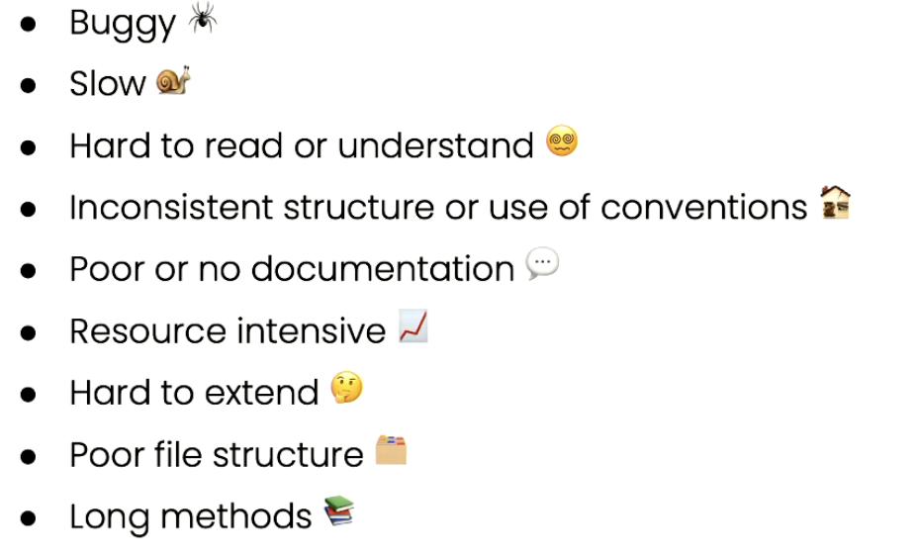
Consequences of poor code quality
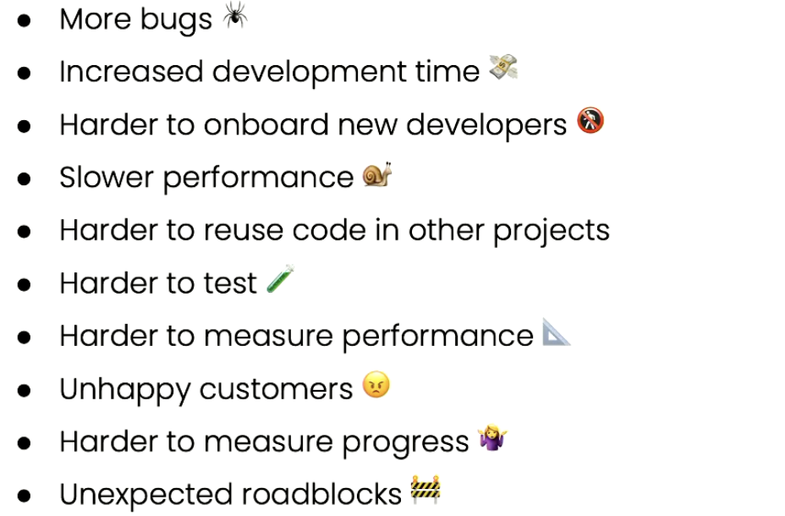
Coding practices & conventions
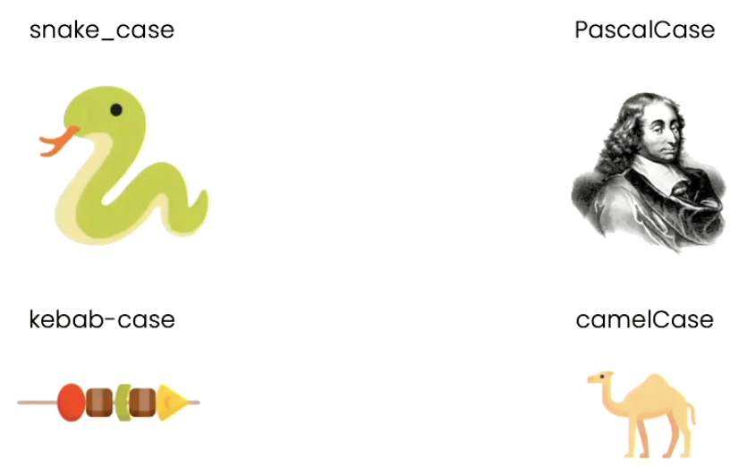

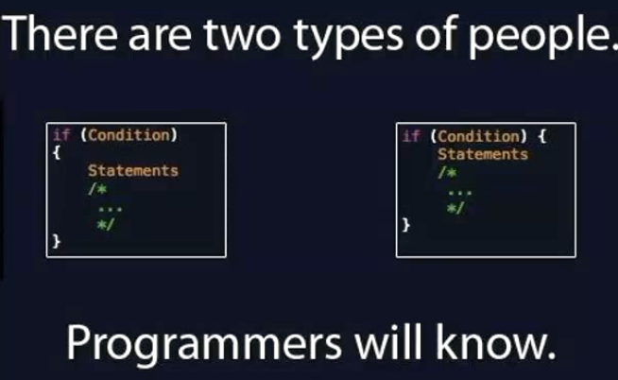
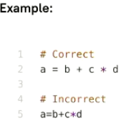

Metrics
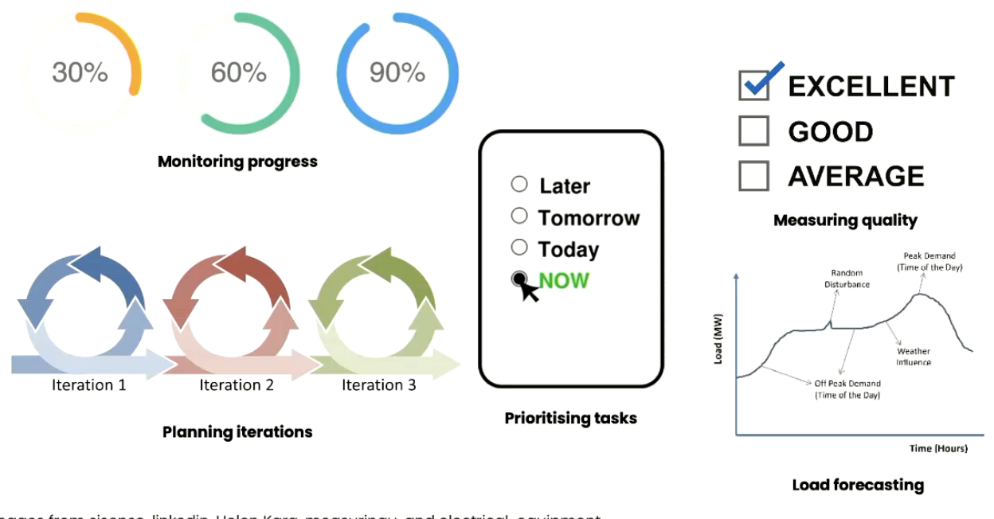

Reliability and validity of metrics
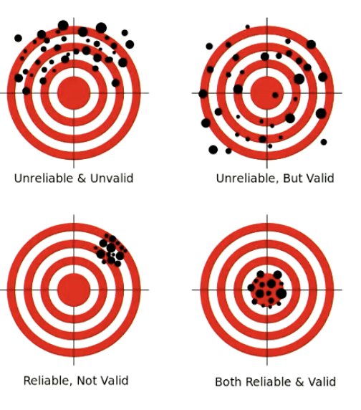
- # Lines of code
- Cyclomatic complexity identifies problem areas
  - Compare to different parts of the code
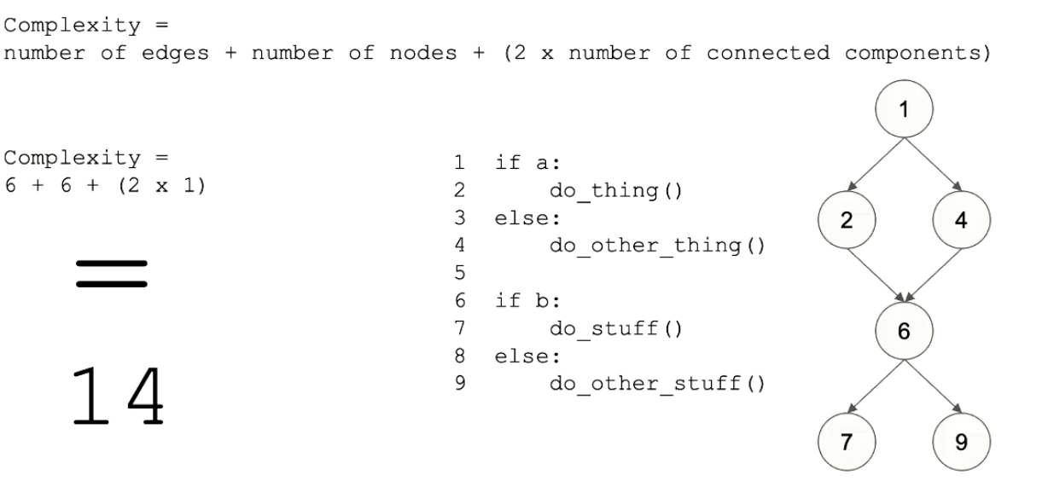
Should be #edges - #nodes + 2 * CC
- Halstead complexity measures difficulty
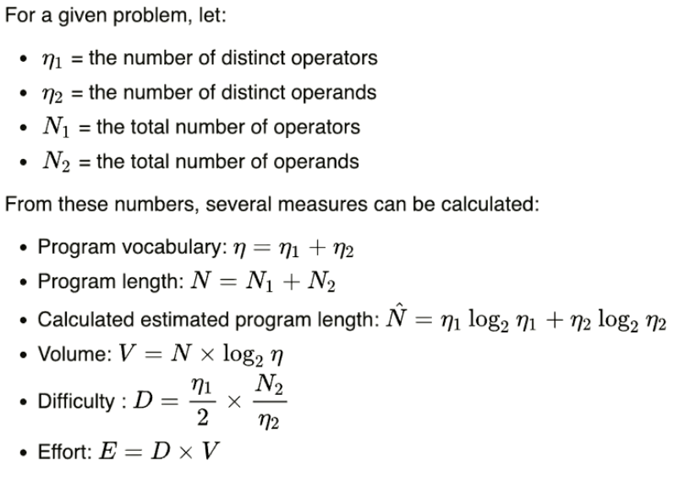
Test metrics
- Test efficiency measures how resources were used
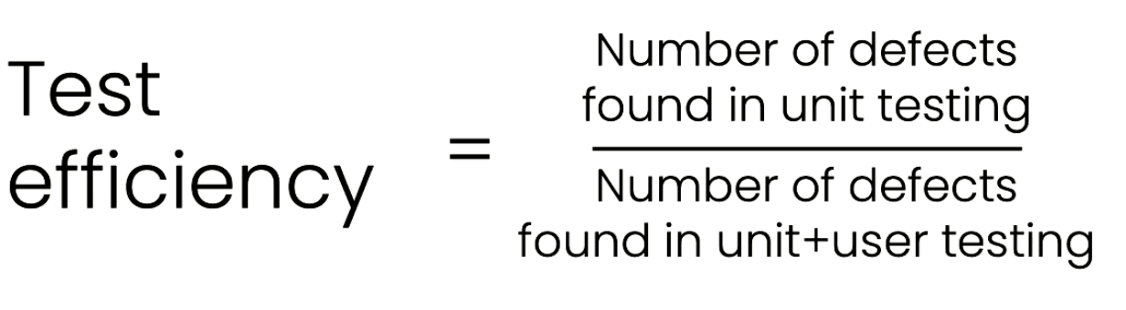
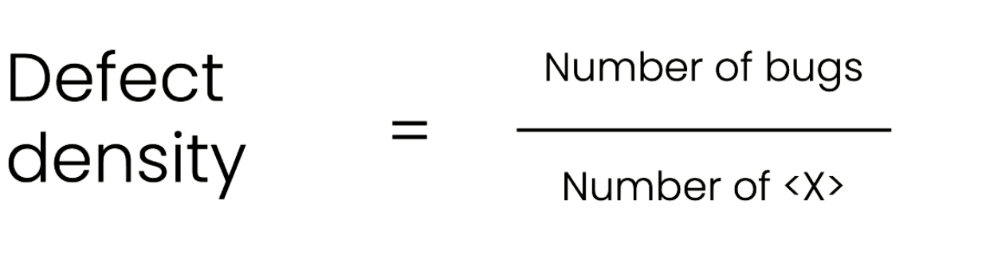
- Mutation testing measures test quality
